**Region: Galway**

**After 3 qualifiers**

**Contact: Billy O Reilly, 0868216207**

**Galway Region**

**Contact: Billy O Reilly, 0868216207**

**Region: Mayo**

**After 3 qualifiers**

**Contact: Billy O Reilly, 0868216207**

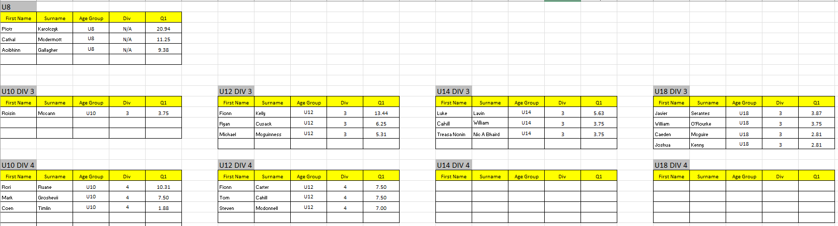

**Region: Sligo**

**After 3 qualifiers**

**Contact: Billy O Reilly, 0868216207**

**Region:Donegal**

**After 3 qualifiers**

**Contact: Billy O Reilly, 0868216207**

**Region: Waterford**

**After 2 qualifiers**

**Contact: Billy O Reilly, 0868216207**

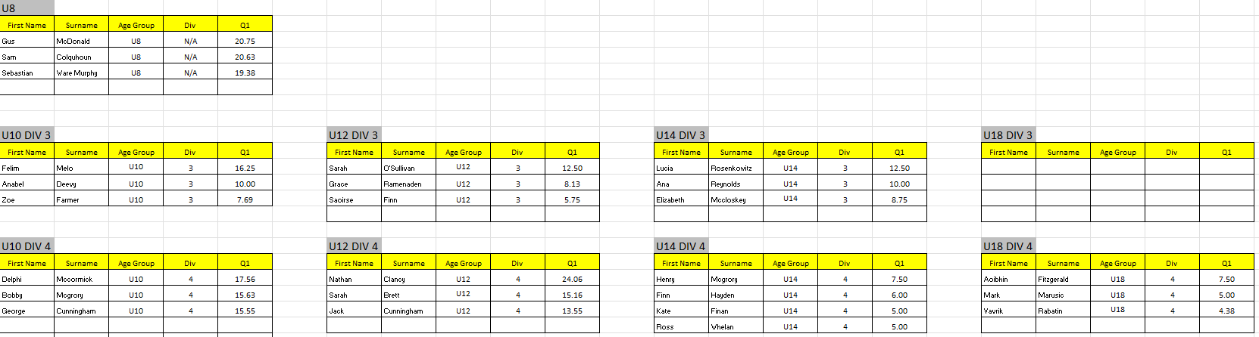

**Region: Longford**

**After 3 qualifiers**

**Contact: Billy O Reilly, 0868216207**

**Region: Tipperary**

**After 3 qualifiers**

**Contact: Billy O Reilly, 0868216207**

**Region: Limerick**

**After 2 qualifiers**

**Contact: Billy O Reilly, 0868216207**

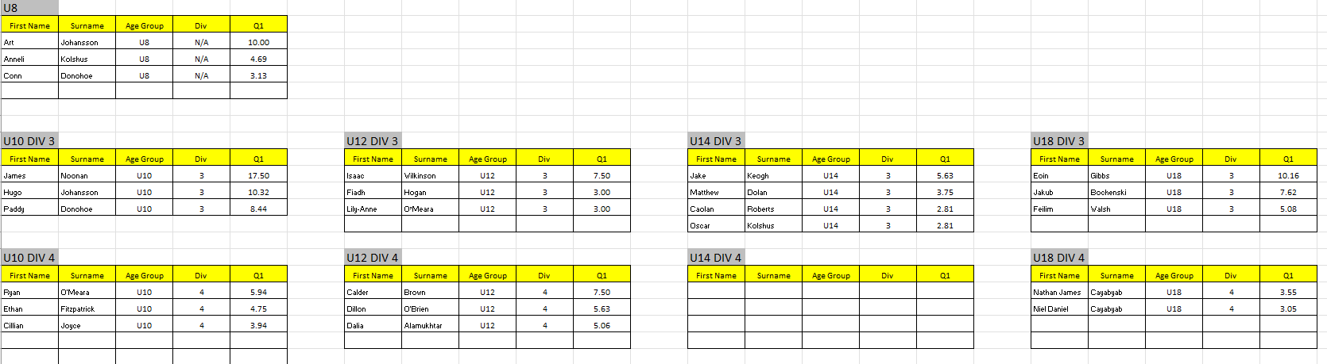

**Region: Clare**

**After 1 qualifiers**

**Contact: Billy O Reilly, 0868216207**

