
Region: Galway
After 4 qualifiers
Contact: Billy O Reilly, 0868216207
Galway Region
Contact: Billy O Reilly, 0868216207

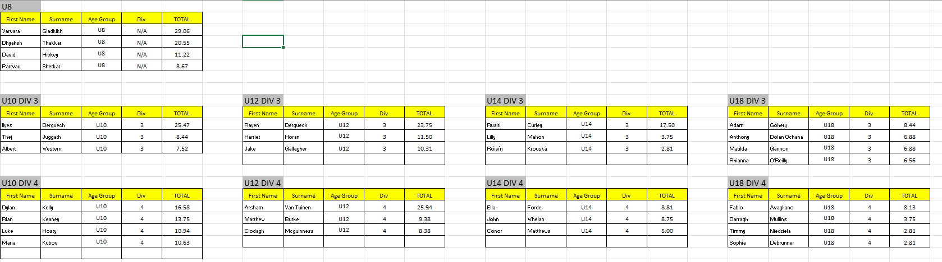

Region: Mayo
After 4 qualifiers
Contact: Billy O Reilly, 0868216207

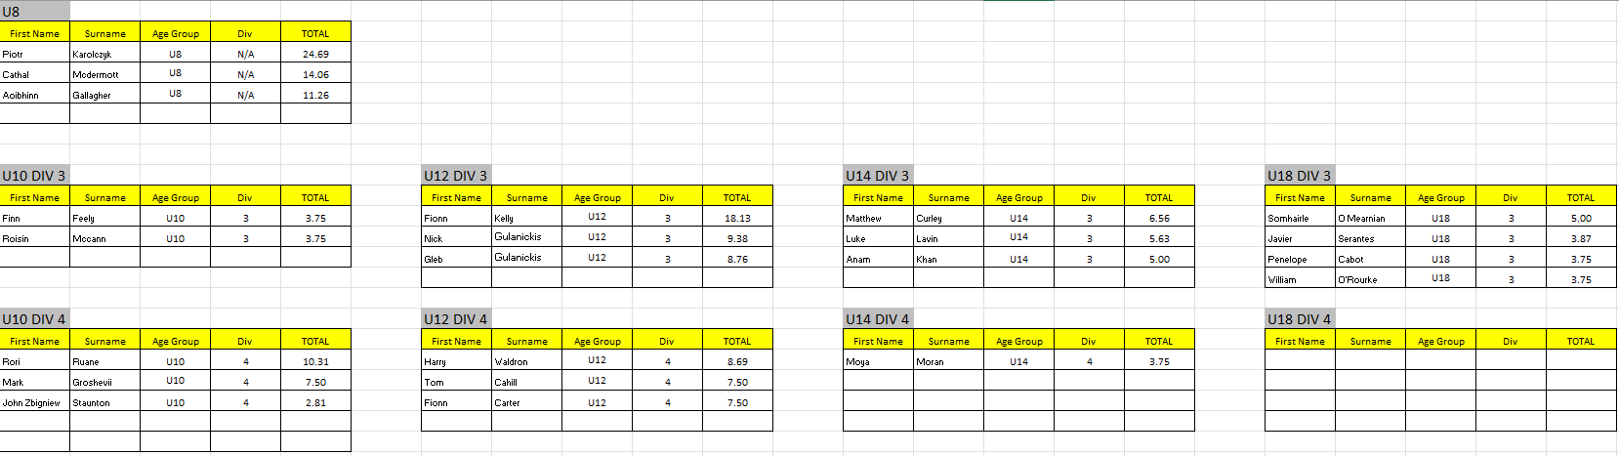

Region: Sligo
After 4 qualifiers
Contact: Billy O Reilly, 0868216207

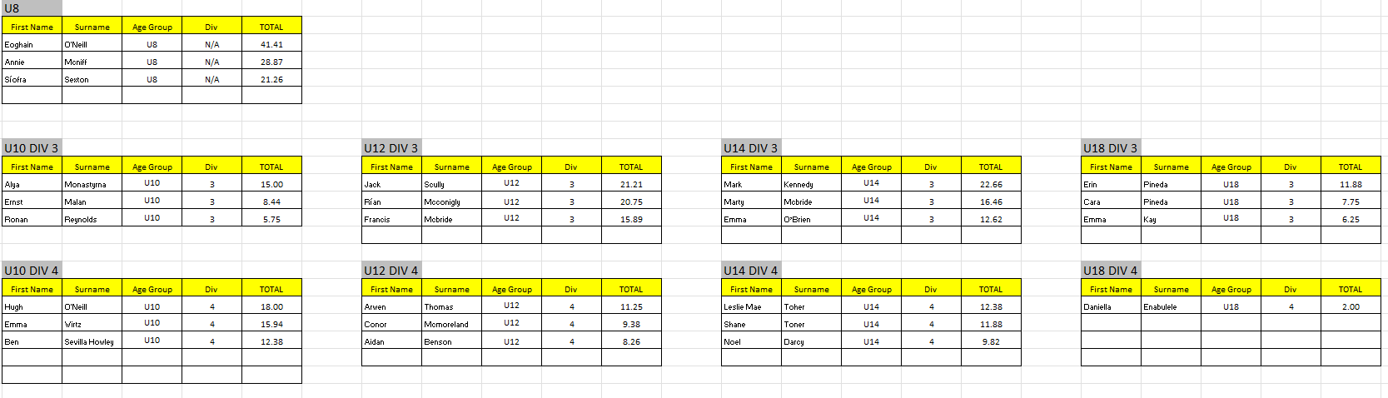

Region:Donegal
After 4 qualifiers
Contact: Billy O Reilly, 0868216207

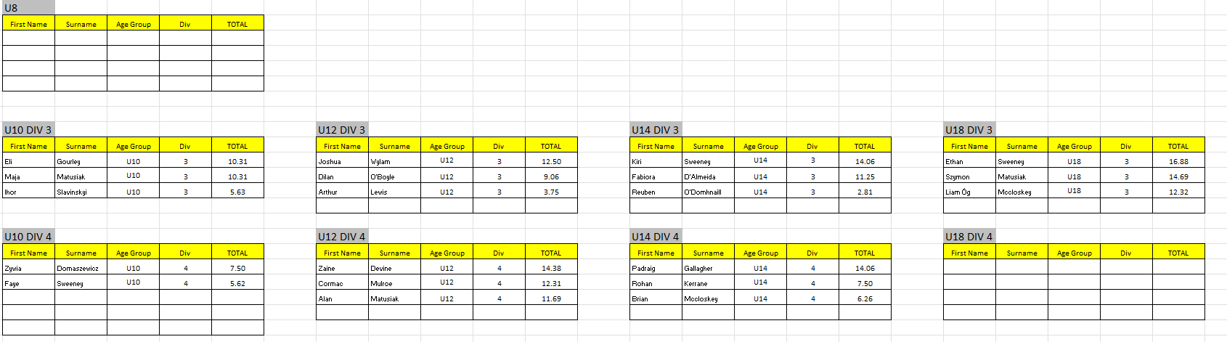

Region: Waterford
After 4 qualifiers
Contact: Billy O Reilly, 0868216207
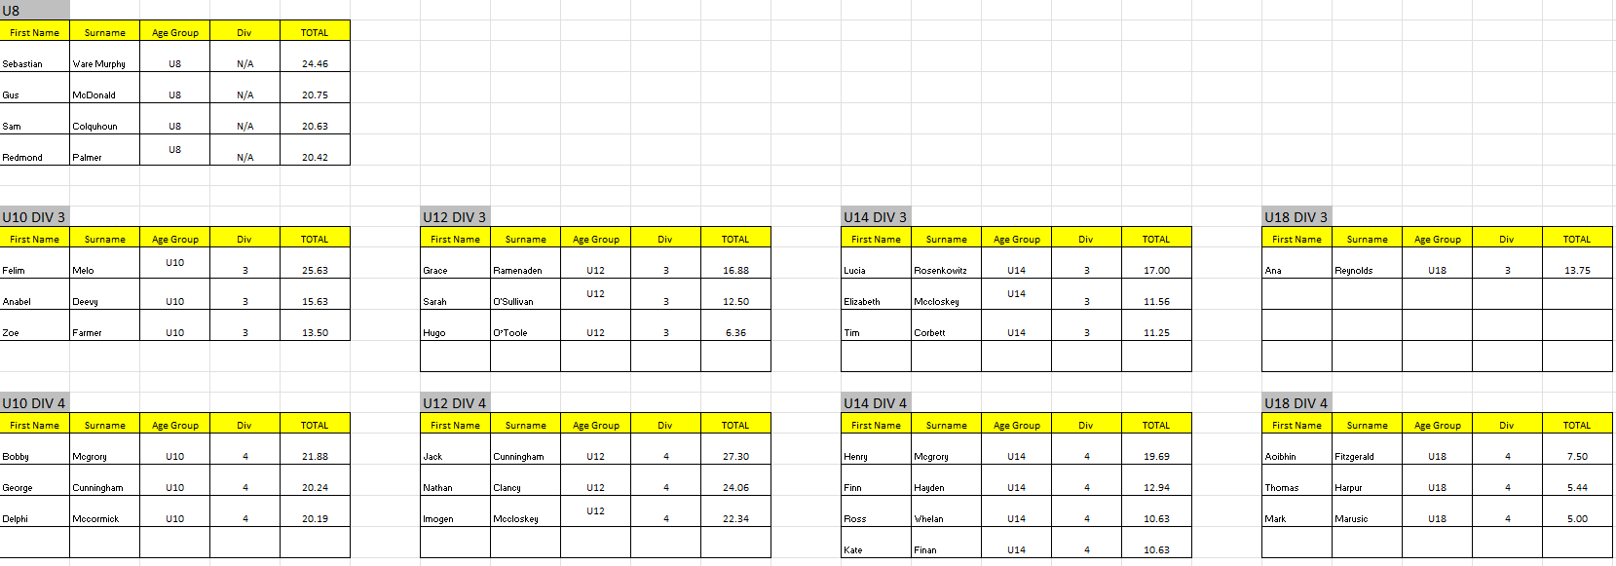

Region: Longford
After 4 qualifiers
Contact: Billy O Reilly, 0868216207

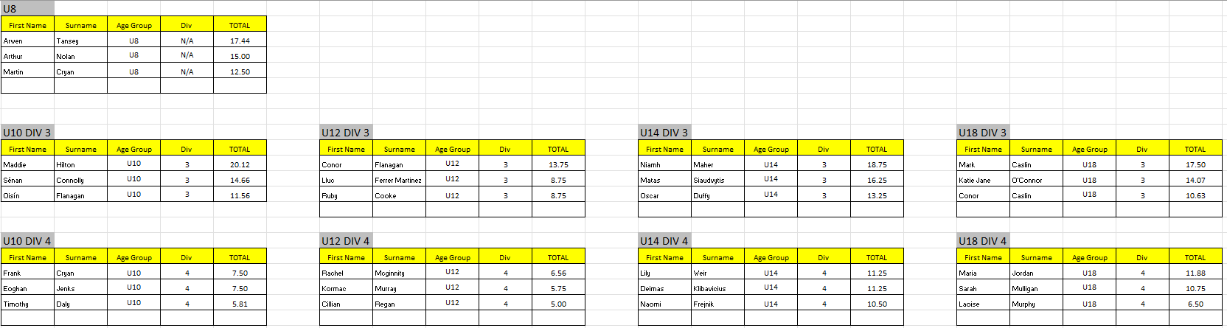

Region: Tipperary
After 4 qualifiers
Contact: Billy O Reilly, 0868216207

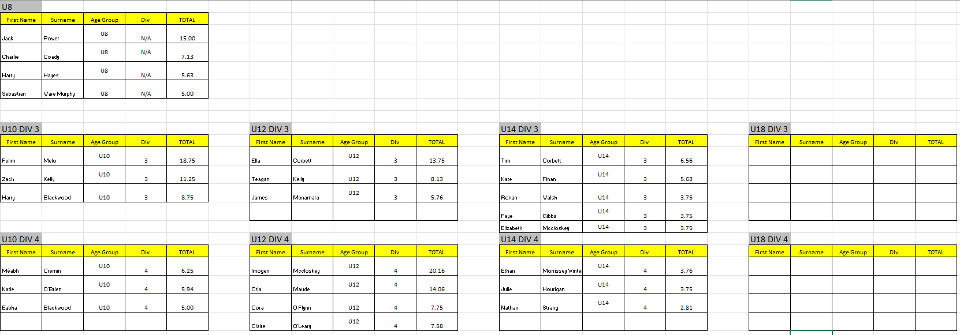

Region: Limerick
After 4 qualifiers
Contact: Billy O Reilly, 0868216207

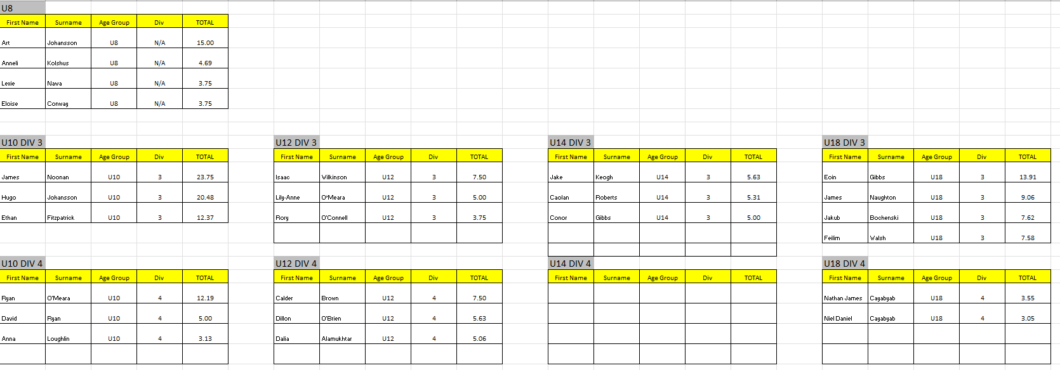

Region: Clare
After 4 qualifiers
Contact: Billy O Reilly, 0868216207

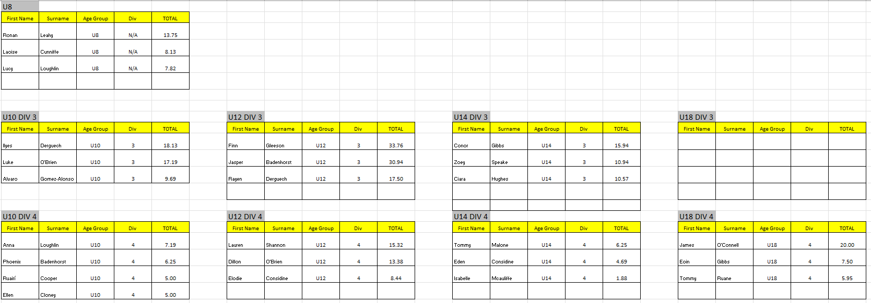
NEXT GEN SERIES

Region: Carlow
After 3 qualifiers
Contact: Billy O Reilly, 0868216207
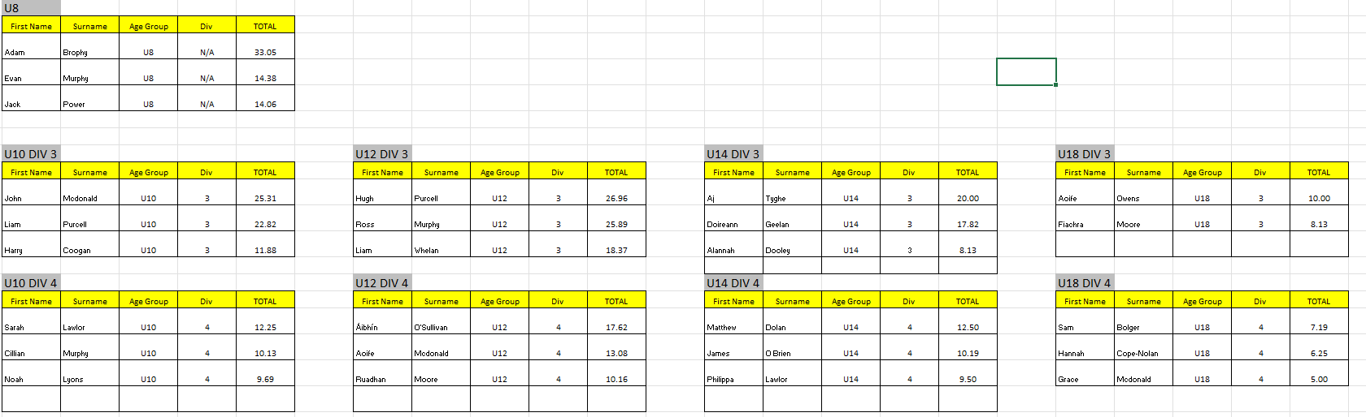

NEXT GEN SERIES

Region: Cork
After 2 qualifiers
Contact: Billy O Reilly, 0868216207

